**REPORT ON SUPERMARKET DATASET (INVOICE, ORDER LEADS, SALES TEAM)**

1. **KEY FINDINGS.**

* IDENTIFYING THE MOST PROFITABLE CUSTOMER SEGMENT BASED ON ORDER VALUE AND CONVERTED SALES
* ANALYZING THE CONVERSION RATE OF ORDERS OVERTIME TO OPTIMIZE PROMOTIONAL STRATEGIES AND PRODUCT OFFERING ACCORDINGLY

1. Based on my analysis using BIGQUERY, the most profitable customer segment (type of meal) is DINNER. With this insight, you can advise stakeholders to promote DINNER meals more at the supermarket, offer discounts from time to time to encourage already buying customers and attract new customers. This can help stakeholders to better allocate their funds to where it is more profitable (DINNER MEALS) and try to improve on other Meal Types (LUNCH AND BREAKFAST MEALS).
2. The conversion Rate of orders over time is very low based on my analysis in BIGQUERY (total number of order is 100,000 but conversion rate is only 17,029 meaning 82,971 didn’t convert to customers. So stakeholders should advertise to their target customers using the appropriate advertisement platform, giving discounts, rebranding or changing their sales strategies.
3. Data quality issues found were NONE. The data was complete, consistent, accurate and reliable.
4. The challenges I faced where;

* Changing date data type
* Separating names in different columns which were in a single column and organizing them into a single column with their own rows each while maintaining its information in other tables.
* Writing queries using commands which are not SELECT, FROM and WHERE.

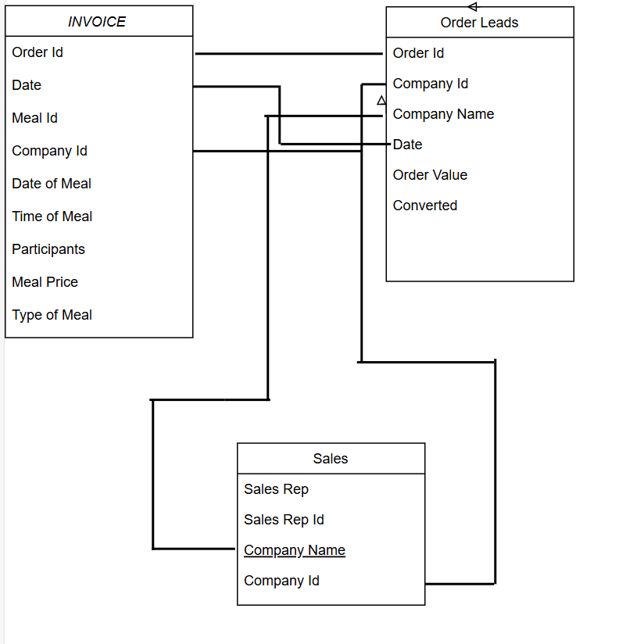

**MANY TO MANY RELATIONAL DATABASE**

**PRIMARY KEYS**

**FOREIGN KEYS** Order id

Order Id Sales Rep Id

Company Id

Date

Company Name